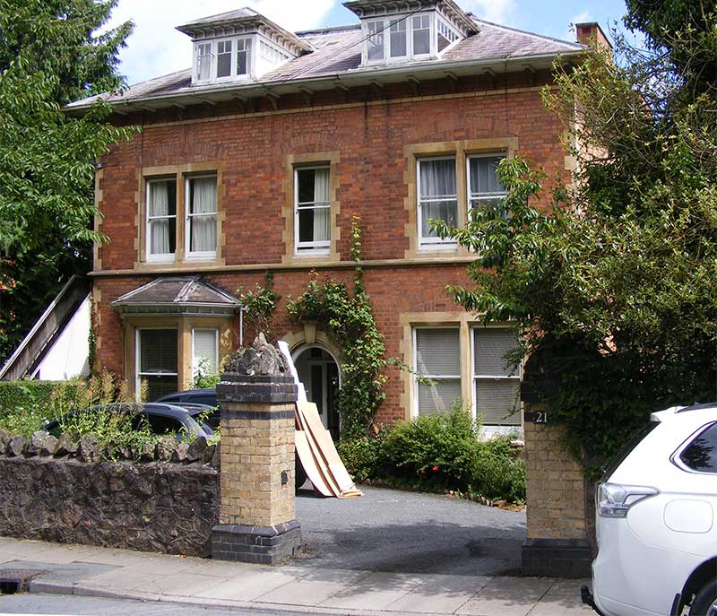
Possibly Hatfield, later Brightside, 21 Priory Road
In 1911 Hatfield was a Nursing and Nurses' home, with Miss Beaumont listed as superintendant; by 1940 Hatfield had been renamed Brightside with the occupier listed as Miss E Horbury; in the 1960s Brightside was listed as a nursing home.
This could be the nursing home where Philip Nicholls, a pupil of Southlea prep school sadly died, aged 11 years, on St Matthias Day 1918; he is remembered in a plaque in Guarlford church and is buried at Wolverley parish church. Click to read more about Southlea school.
In 1944 the Times announced the engagement of John Wheeler-Bennett, whose widowed mother was at Brightside, to Ruth Risher of Charlottesville, Virginia USA. Historian Sir John Wheeler-Bennett GCVO, CMG, OBE, FBA, FRSL, educated at Malvern College, died at London in 1975.

